Content 4

**Strings**

The string is a data type in Python.

A string is a sequence of characters enclosed in quotes.

We can primarily, write a string in three ways:

1. Single quoted strings : a = ‘harry’
2. Double quoted strings : b = “harry”
3. Triple quoted strings : c = ‘’’ harry ‘’’

##### **String Slicing:**

A string in Python can be sliced for getting a part of the string.

Consider the following string:

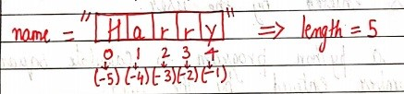

The index in a string starts from 0 to (length-1) in Python. In order to slice a string, we use the following syntax:

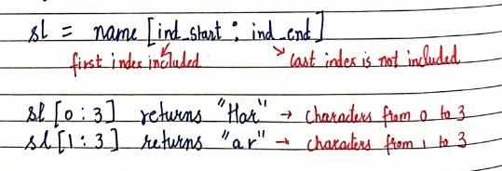

**Negative Indices:**Negative indices can also be used as shown in the figure above. -1 corresponds to the (length-1) index, -2 to (length-2).

**Slicing with skip value**

We can provide a skip value as a part of our slice like this:

word = “amazing”

word[1:6:2]           # It will return ’mzn’

**Other advanced slicing techniques**

word = ‘amazing’

word[:7] or word[0:7]      #It will return ‘amazing’

word[0:] or word[0:7]      #It will return ‘amazing’

##### **String Functions**

Some of the mostly used functions to perform operations on or manipulate strings are:

1. **len() function :**It returns the length of the string.

len(‘harry’)               #Returns 5

1. **endswith(“rry”) :**This function tells whether the variable string ends with the string “rry” or not. If string is “harry”, it returns for “rry” since harry ends with rry.
2. **count(“c”) :**It counts the total number of occurrences of any character.
3. **capitalize() :**This function capitalizes the first character of a given string.
4. **find(word) :**This function finds a word and returns the index of first occurrence of that word in the string.
5. **replace(oldword, newword)** : This function replaces the old word with the new word in the entire string.

##### **Escape Sequence Characters:**

Sequence of characters after backslash ‘\’ [Escape Sequence Characters]

Escape Sequence Characters comprises of more than one character but represents one character when used within the string.

Examples: \n (new line), \t (tab), \’ (single quote), \\ (backslash), etc.

str1 = '''Are you Going'''

str2 = ''' to the Market.'''

str = str1 + str2       #adding the upper strings

print("The input string is:~~~  ", str)

# if here I want one char then I will look it throught index of string

print(str[0])

print(str[1])

print(str[2])

print(str[3])

# Another syntax for reading string throught index

print("\n\nThe another Syntax for ",str[0:6])

#Escape value

print("\n\nThe Escape Value: ",str[0:10:2]) #it will skip every 2nd time value

print("\n\nThe length of string: ",len(str))

print("Shows the last word if its same gives: ",str.endswith("Market"))

print("The Total numbers of a present in ",str.count("a"))

print("Capitalization of first letter: ",str.capitalize())

print("Finding the word: ",str.find("going"))

print(str.replace("Going to",("gonna")))

**Output:**

The input string is:~~~ Are you Going to the Market.

A

r

e

The another Syntax for Are yo

The Escape Value: AeyuG

The length of string: 28

Shows the last word if its same gives: False

The Total numbers of a present in 1

Capitalization of first letter: Are you going to the market.

Finding the word: -1

Are you gonna the Market.

